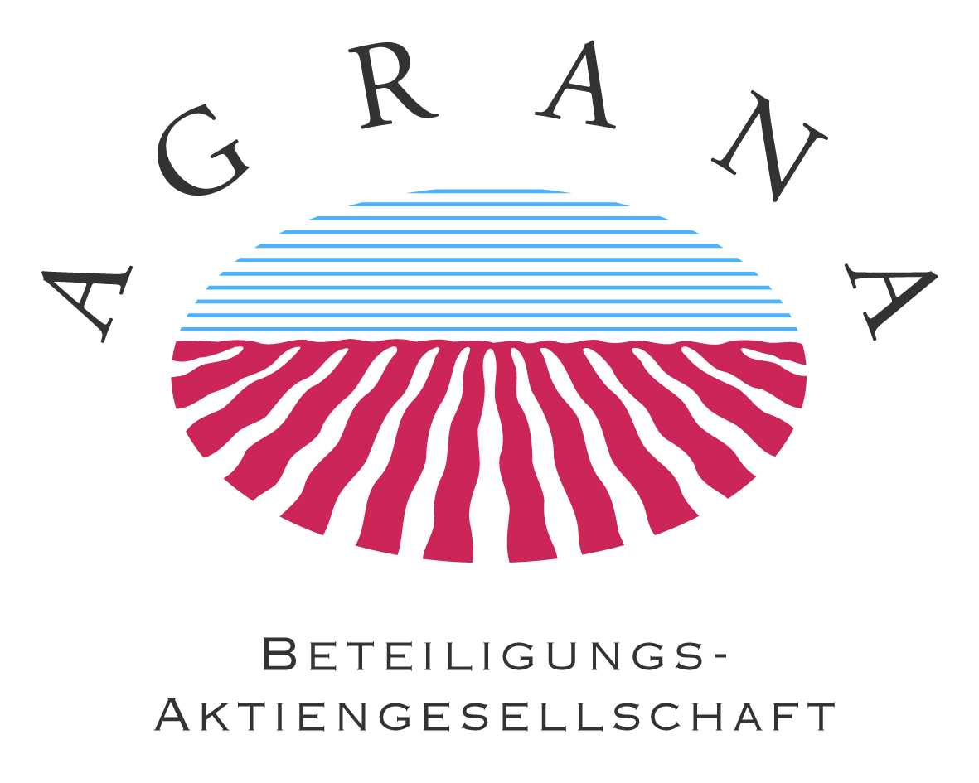

PRESS RELEASE

Vienna, November 13, 2008

AGRANA – New member of the Board of Management
Supervisory Board appoints Fritz Gattermayer effective January 1, 2009 and confirms investment programme of approx. EUR 75m for the current fiscal year 2008|09

In its meeting on November 13, 2009, AGRANA Beteiligungs-AG’s Supervisory Board elected Fritz Gattermayer a new member of the company’s Board of Management effective January 1, 2009. The 51-year old agricultural economist will join the current Board of Management consisting of its Chairman and Chief Executive Officer of AGRANA Beteiligungs-AG, Johann Marihart, Chief Financial Officer, Walter Grausam, and Thomas Kölbl, as its fourth member.

Fritz Gattermayer joined AGRANA Beteiligungs-AG in 1992. Most recently he was the Chief Executive Officer of the Group’s Sugar segment. As a member of AGRANA Beteiligungs-AG’s Board of Management, Fritz Gattermayer will be responsible for Purchasing and Sales, as well as Raw Materials.

The Supervisory Board has decided to increase the number of members of the Board of Management in order to keep pace with the Company’s dynamic development in the last years, and to signal the continuation of its strategy in the future. In the fiscal year 2008|09 AGRANA expects its total revenues to increase from EUR 1.9 billion to EUR 2.1 billion. Following the massive investment programme in the last two years, the Company will reach its normalised capital expenditure level of approx. EUR 75 million in the current fiscal year.

This press release is available in German and English on the Internet at www.agrana.com.

